# CS 255 System Design Document Template

This template lays out all the different sections that you need to complete for Project Two. Each section has guidance to prompt your thinking. You will need to continually reference the interview transcript as you work to make sure that you are addressing your client’s needs. There is no required length for the final document. Instead the goal is to complete each section based on what your client’s needs are. Remove this note when you are finished, and replace all bracketed text with the relevant information.

## UML Diagrams

### UML Use Case Diagram

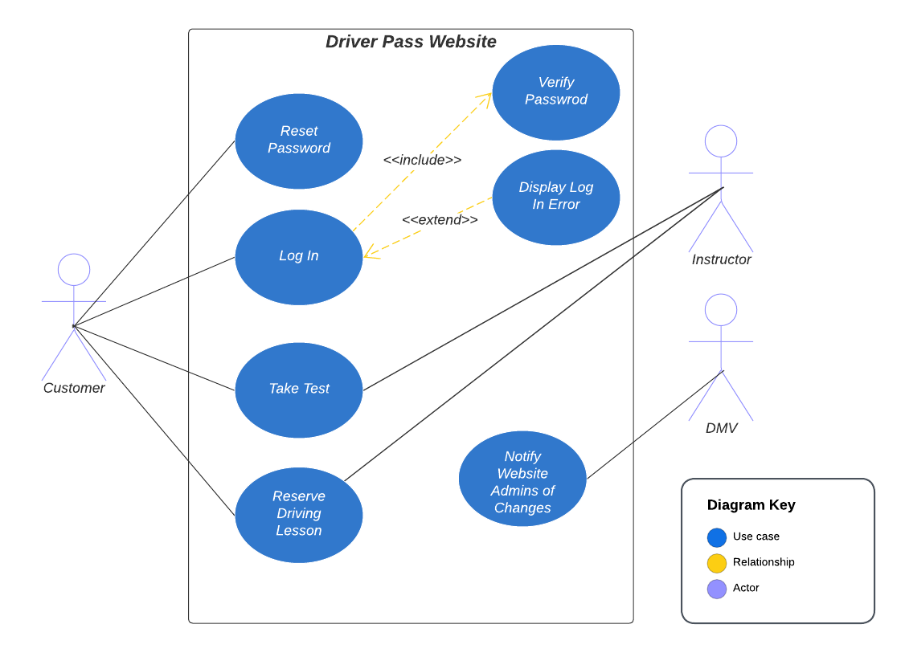

### UML Activity Diagrams

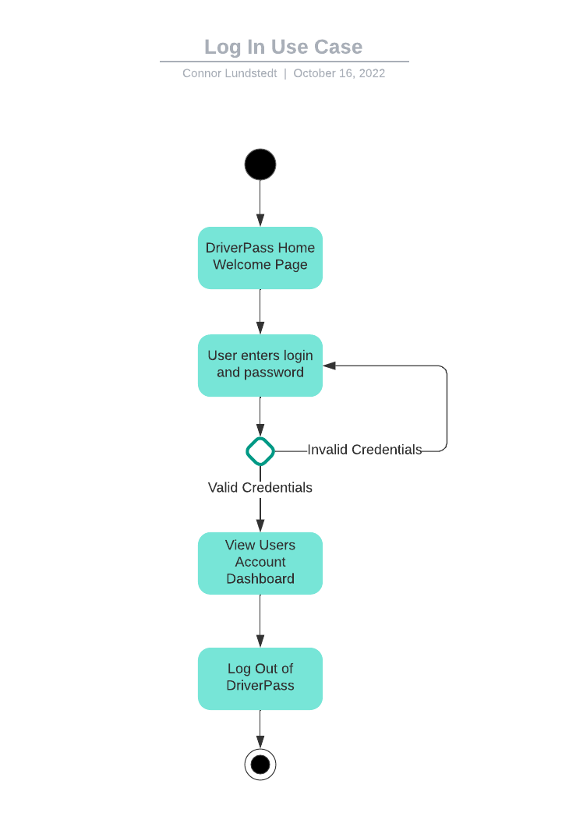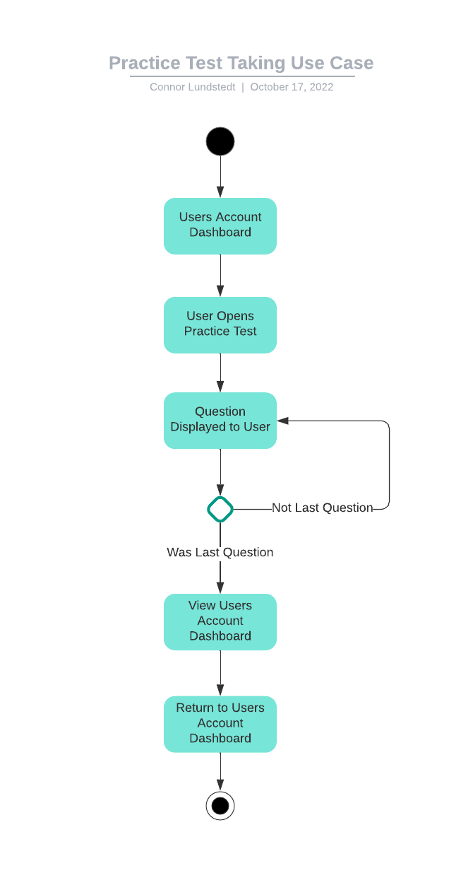

### UML Sequence Diagram

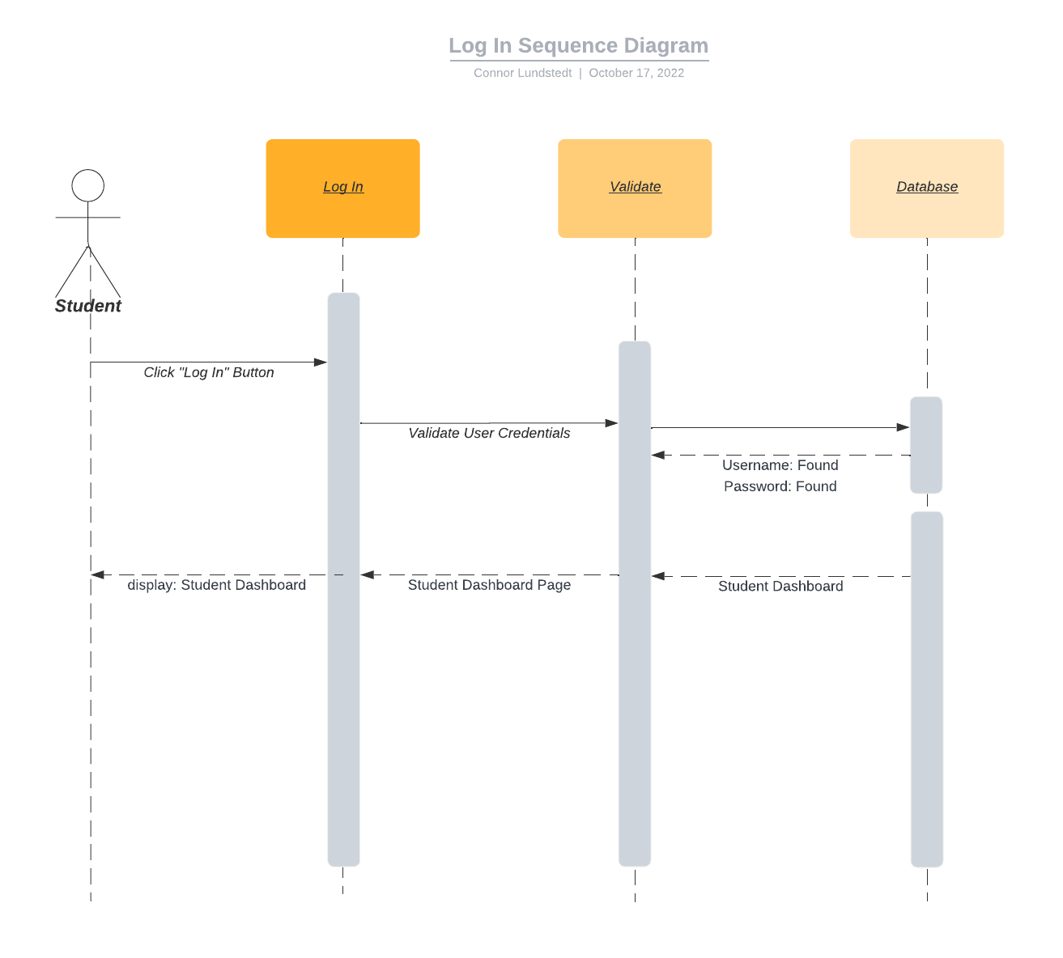

### UML Class Diagram

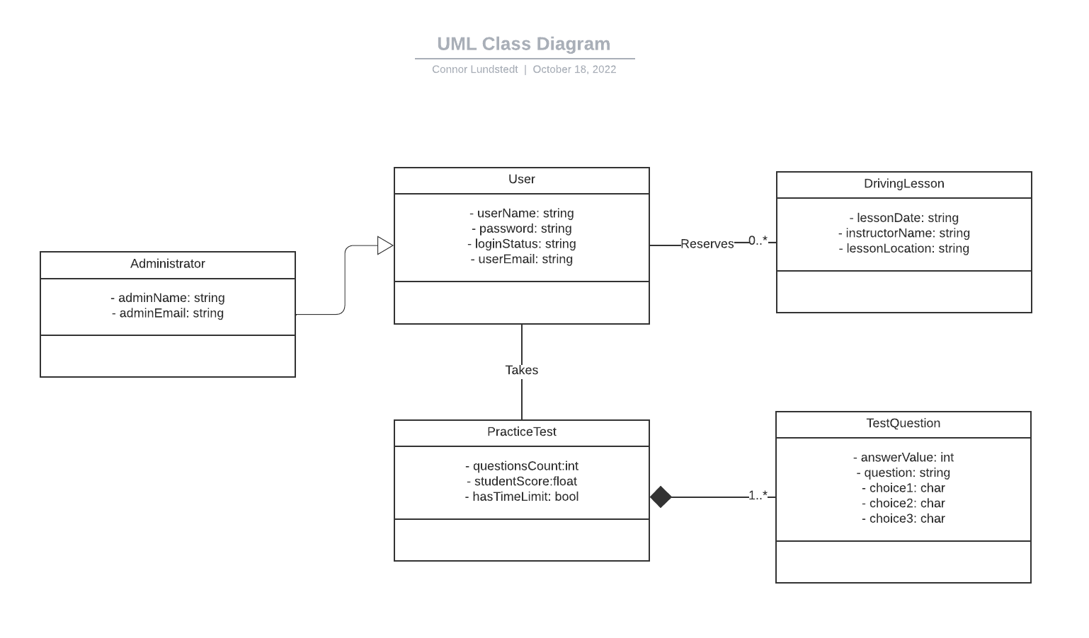

## Technical Requirements

The technical requirements of this system are tailored for a web-based platform that can run on both desktop and mobile devices. This web-based system currently assumes no mobile application and should run on most modern web browsers. This system should also have a responsive front-end for the user to maintain usability on mobile touch-based devices. The website’s structure and layout should remain the same as much as possible across platforms however in order to reduce any confusion. Using this system, users can take practice tests, online classes, and reserve driving lessons with instructors. Given this is a web-based platform, languages such as HTML, CSS, JavaScript, PHP, and SQL are likely to be used in some capacity. The back end of this system will use a cloud-based solution for the storage of each user’s important data, such as test scores and driving lesson reservations. Administrator accounts should also be able to access and print activity reports from the system. All the users of this system also rely on updates when the DMV changes any rules or policies in order to keep things up to date.